**Tut_9_20103153_AVNI_ARORA _B6**

1)

#include <iostream>

using namespace std;

int main()

{

int age;

cout<<"Enter age:";

cin>>age;

try

{

if(age>=18)

{

cout<<"Access granted - you are old enough.";

}

else

{

throw age;

}

}

catch(int i)

{

cout<<"Access denied - You must be at least 18 years old.\nAge is:"<<i;

}

return 0;

}

Output:

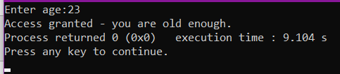

2)

#include <iostream>

using namespace std;

double zeroDivision(int x, int y) {

if (y == 0) {

throw "ERROR\n Division by Zero is not possible ";

}

return (x / y);

}

int main() {

int a,b;

cout<<"Enter numerator: ";

cin>>a;

cout<<"Enter denominator: ";

cin>>b;

double c;

try {

c = zeroDivision(a, b);

cout <<"Division: "<<c << endl;

}

catch (const char* m) {

cerr << m << endl;

}

return 0;

}

Output:

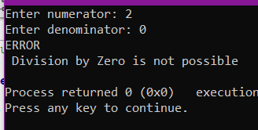

3)

#include<iostream>

using namespace std;

int main()

{

int num1 , num2 ;

while(1){

cout<<"Enter number 1: ";

cin>>num1;

cout<<"Enter number 2: ";

cin>>num2;

try {

if(num1 == (-1*num2) )

throw 1;

else

break;

}

catch(int n) {

cout<< " Invalid numbers\nEnter different numbers "<<endl;

}

}

double h;

h = 1.0/( (1.0/num1 + 1.0/num2)/2.0 );

cout<<" harmonic mean of given number is : "<<h<<endl;

}

Output:

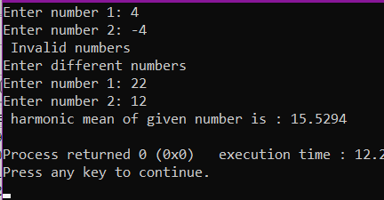

4)

Output:

catch StringOK

catch 1 0

5)

Output:

default exception

After Exception

6)

Output:

c) Exception occurred: Thrown value is -1

because the value of x=-1 and according to the code throw statement will get executed which will be catched by a the suitable catch statement given so this output will occur as exception is arised here.

7)

C) Only i, iv